34.73: a) R < 0 for convex so 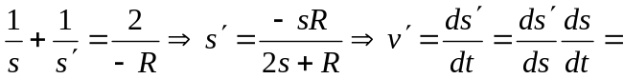
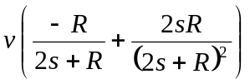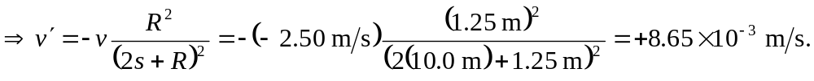
b) 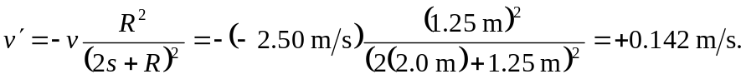
Note: The signs are somewhat confusing. If a real object is moving with v > 0, this implies it is moving away from the mirror. However, if a virtual image is moving with v > 0, this implies it is moving from “behind” the mirror toward the vertex.

